EXPERIMENT – BFS (BREADTH FIRST SEARCH )

AIM
To develop a Python program to implement the Breadth First Search (BFS) algorithm for graph traversal.

OBJECTIVE
To demonstrate how the Breadth First Search (BFS) algorithm visits all vertices of a graph level by level.

ALGORITHM
- Start.
- Create the graph, choose the starting vertex, and insert it into a queue.
- Remove a vertex from the queue, mark it as visited, and display it.
- Insert all unvisited adjacent vertices into the queue and repeat until the queue becomes empty.
- Display the BFS traversal order and
- Stop.

SAMPLE CODE

from collections import deque

graph = {
'A': ['B', 'C'],
'B': ['D', 'E'],
'C': ['F'],
'D': [],
'E': ['F'],
'F': []
}

visited = set()
queue = deque()

start = 'A'
visited.add(start)
queue.append(start)

print("BFS Traversal:")

while queue:
node = queue.popleft()
print(node, end=" ")

for neighbour in graph[node]:
if neighbour not in visited:
visited.add(neighbour)
queue.append(neighbour)
FLOW CHART

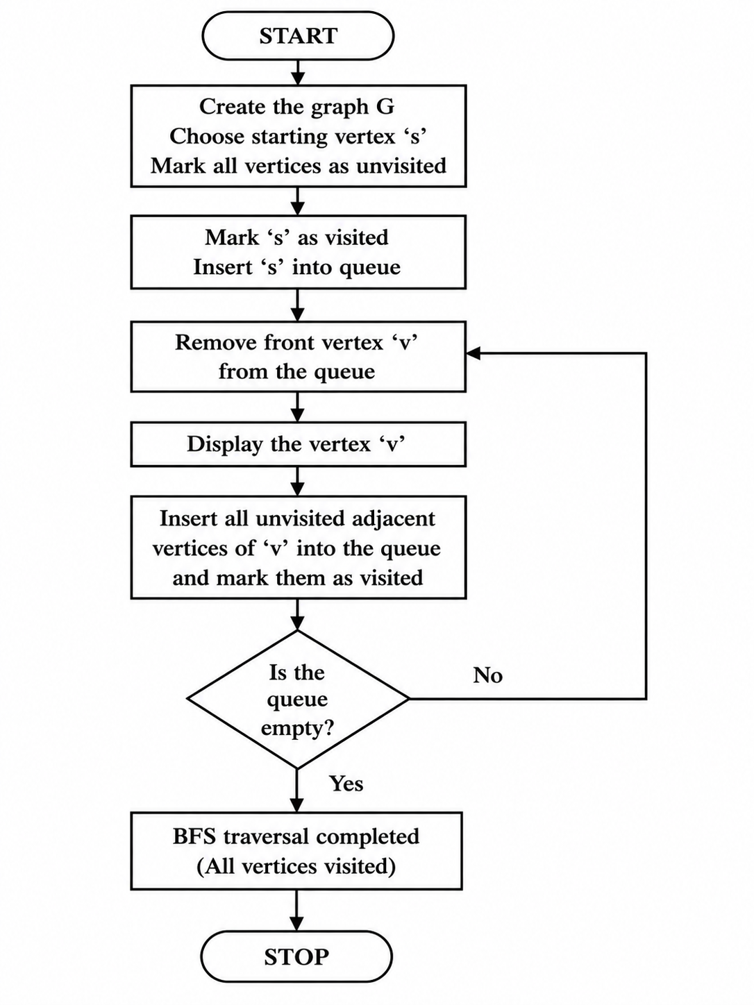
OUTPUT

RESULT
The Python program was executed successfully. The Breadth First Search (BFS) algorithm traversed the graph level by level and visited all reachable vertices from the starting node.

